DATABASE MANAGEMENT
WITH

MICROSOFT
ACCESS

TRAINING NOTES

TABLE OF CONTENTS

Section 1: Introduction to Access 4
What is Access? 4
A note on versions 5
A quick database 5
Starting up and creating a blank database 5
Using wizards to create a table and form 5
Using the data entry form 6
Navigating through the table 7
Sorting 7
Searching 8
The Find command 8
Using a Filter 8
Querying the database 9
The query wizard 9
Modifying the query 10
Reports 10
Change the query ... 11
... and look at the Report 11
Summary 12
Section 2: Create a table and form for data entry 13
Create a table 13
Create a data-entry form 15
Enter Data 15
Example 16
Re-think the structure of the data 21
Section 3: Notes on database design 23
Links between tables 23
Example 1 – The Art Club 23
Scenario 23
The artist table 23
The picture table 24
The purchaser table 24
Notes 25
Example 2: The conference database 26
Scenario 26
The people table 26
The contribution table 26
The pclink table 26
Notes 27
Section 4: Querying a database 29
The movie1 Database 29
Open the database 29
Look at the movie and actor tables 29
Querying the database 29
Querying the movie table 29
Comparison operators 31
Save your query 31
A linked-table query 32
A more complicated example 33
(a) List the movies where the director is known 33
(b) Compare directors and actors 34
A query based on other queries 34
Modify the two queries 34
Creating the new query 35
AND and OR 35
SQL 39
Section 5: Data entry into linked tables 41
The fully linked database 41
Open the database 41
See how the tables are linked 41
Referential Integrity 42
Keyed fields 42
Enforcing referential integrity in the Relationships window 42
The data-entry form 43
Adding records 44
What is happening when we enter records on the form? 45
Deleting records 45
Section 6: Setting up linked tables 47
Open the database 47
Establish referential integrity 47
The actor table 47
The movie table 47
The movact table 47
Setting up the Relationships 48
Creating the form 48
The linking query 49
The Form wizard 49
A combo box 50
Section 7: Simple Reports 52
A simple report 52
The Properties window 53
Modify the simple report 55
(a) Add a heading in the Page Header section of the report 55
(b) Bring the rows closer together 55
Aligning your text-boxes 56
Grouping the fields 57
A report using the actdirect query 60
Create and use a Switchboard. 61
Section 8: MACROS 63

Section 1:
Introduction to Access
Any information held on a computer can be described as a database, but the term is usually reserved for information that is structured in a way that makes it easy to store, retrieve and search. The easiest way of picturing the structure of a database is to think of a table with rows and columns. In database terminology the rows are known as records and the columns as fields.
Most databases consist of several tables linked together. Here are two linked tables.

Author no. | First name | Last name | year of birth | year of death
1 | Charles | Dickens | 1812 | 1870
2 | George | Orwell | 1905 | 1949

Author no. | Title | year of publication
1 | Great Expectations | 1861
1 | David Copperfield | 1850
1 | Dombey & Son | 1848
2 | Animal Farm | 1945
2 | 1984 | 1948

Questions
- If we call the first table the author table, what would you suggest we call the second table?
- How many fields are there in the author table, and how many in the second table?
- Can you guess what enables the database program to link these two tables?
- Why do you think we don’t put all this information into a single table?
- What assumption are we ma
- king when we use the author number field to identify the author of a publication?

What is Access?
Access is a DataBase Management System (DBMS) which enables us to
- create tables and enter data into them
- specify relationships between the tables
- interrogate the data
- create forms providing easy views of the data
- create report layouts to print out selected parts of the data in understandable and presentable formats
- create free-standing applications with their own customised interface so that the “end-users” do not need to learn how to use Access

A note on versions
These notes refer to Access2000 because earlier versions are not compatible with the networking system in the PC classrooms. Most users in St Andrews still have Access97. The differences between the versions are slight. Access2000 can open and use databases created with the earlier version, and can save a database in a format which the earlier version can handle.

A quick database
The following instructions illustrate the simplest possible use of Access. We shall create a database consisting of a single table. Wherever possible, we shall accept the default options offered by Access.

Starting up and creating a blank database
- Choose Programs from the Start menu and then choose Microsoft Office, and then Microsoft Access
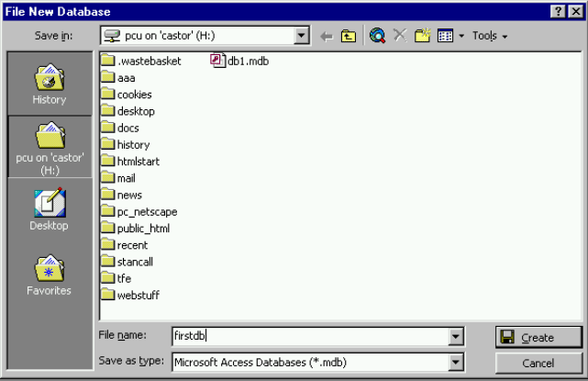
- In the initial dialog-box select the Blank Database option and click OK
- The first thing you are asked to do is file the new database – that is, save it on disk: complete the dialog-box as usual
- in the Save In: box select your floppy disk or your “home directory” (the H drive)
- in the File Name: box type a name: firstdb
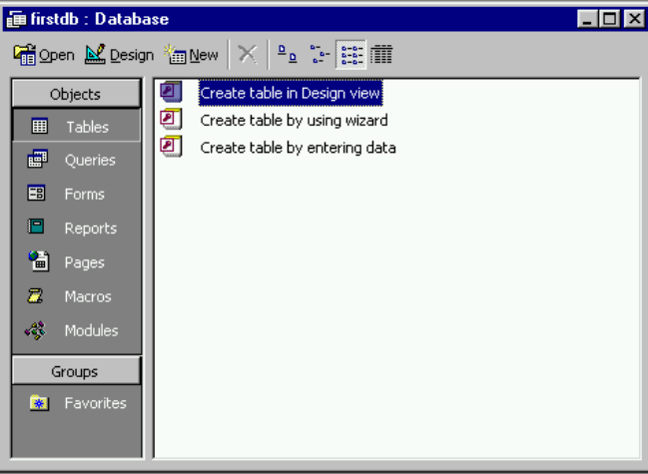
- click Create

After a brief delay Access will display the database window, which is where all the components of the firstdb database will be listed. Note the different sorts of object listed down the left side of the box. To start with Tables are selected. Tables are the basic element of a database. The window offers us three different ways of creating a new table.

Using wizards to create a table and form
The first thing is to create a table and its related form. We shall use a “wizard” which will offer us a range of sample tables, and so save us having to think much about the structure of the table.
- Make sure Tables is selected in the database window
- Double-click the Create a table using Wizard option in the database window
The Table Wizard contains a range of sample tables. These are pre-defined tables which you would probably not want to use in real life, but which will enable us to create a table very quickly. Later sections will tell you how to define tables for yourself.
- 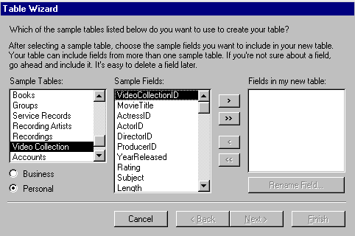Click the Personal option (bottom-left of the dialog-box)
- Scroll down the list of Sample Tables and select Video Collection
- Access will display a list of Sample Fields for the Video Collection table
- in the Sample Fields list click VideoCollectionID
- click the single-arrow > to transfer the selected field into the Fields in My New Table box
Make sure you click the right-pointing single arrow. If you use the double arrow you will transfer all the sample fields
- select MovieTitle and click >
- select YearReleased and click >
- select Subject and click >
- scroll down through the Sample Fields, select Notes and click >
- You should now have five fields listed in the Fields in my new table box, which is enough for now, so click Next
- In the next dialog-box accept the suggested table name and accept default option for creating a primary key: just click Next
- In the final part of the Wizard, select the option Enter data into the table using a form that the wizard creates for me
- Click Finish
Remember, the fields correspond to the columns of a printed table. If you were creating a table to be printed on paper you would have to decide how wide each of the columns should be, and what sort of information each column should contain. Similarly, when you create a table in Access you have to specify the format of each field. The Wizard has done all this for you this time.

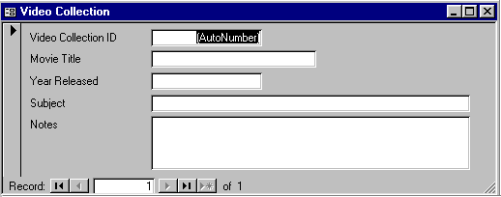Using the data entry form
The Wizard has not only defined the table, but has also designed a data-entry form. After a short delay this form will be displayed.
You move from field to field by pressing the Tab key. For most fields the Return key will have a similar effect, but in fields containing extended text (called “Memo” fields) the Return key does not have the effect of moving to the next field.
- The flashing cursor is in the Video Collection ID field, which contains the highlighted text (AutoNumber): press Tab
- This takes you down to the next field: type in a movie title, for instance Ice Cold in Alex
- Press Tab to get down to the next field, which is Year Released
Note that the AutoNumber has been replaced by the number 1: Access has defined this field as an Automatic numbering field, and will increase the number each time you add a new record.
- Enter the year the movie was released: 1960 and press Tab
- We shan’t enter data in any more fields, so press Tab twice, which will bring you on to the next record with the cursor back in the Video Collection ID field
- Press Tab to go down to the Movie Title field and type in another title, for example The Graduate
- Press Tab – notice that the Video Collection ID is for this record is 2
- In the Year Released field enter 1967
- Press Tab to work down to the end of the record and move on to add a third record
- Again just enter data for the title and year: Great Expectations released in 1945

Navigating through the table
We now have a table consisting of three records.
- Use the navigation buttons at the bottom of the form window to move back and forth: the five buttons shown in the illustration here are (going from left to right):
- go to first record
- go to previous record
- go to next record
- go to last record
- go to new record (ie start a new record to add new data)
- Try out all the buttons
- Click the New Record button to add a record:
- Title: The Dam Busters
- Year: 1955
- Finally return to the Great Expectations record to add some further information:
- point and click in the Subject field
- enter the following text: Based on the novel by Charles Dickens
- press Tab

Sorting
At present the records are sorted according to the Video Collection ID field, which is the field that Access automatically increases each time you add a new record.
We shall now sort the records into chronological order, starting with the most recent.
- Point and click in the Year Released field: this will tell Access that you want to sort according to the year
- From the Records menu choose Sort and from the sub-menu choose Descending – this means Access will start with the latest and work back
There are two buttons on the toolbar for sorting in ascending or descending order. Can you identify them?

Searching
Searching means locating one or more records in your database which match particular search criteria. There are three ways of searching:
- the Find command in the Edit menu
- the Filter command in the Records menu
- for more complex situations, you need to construct a query

The Find command
We’ll look for all those records which contain the definite article The in their title.
Clear the Match Case option: ignore upper or lower case
Also leave Search Field as Formatted blank
- Point and click in the Movie Title field
- Choose Find from the Edit menu
Enter the search term, the
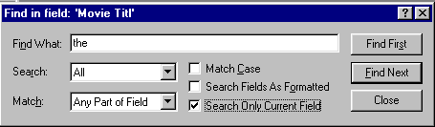
Search all the table, not just up or just down
Look for the search term in any part of the field, not just at the start
Put a tick in Search Only Current Field: we are only interested in the Title field
- Complete the dialog-box as shown
- Click Find First
- When Access finds a record that matches your search term, it displays the matching record, and leaves the Find dialog-box open: click Find Next to find the next occurrence
- Click Find Next again
- There are no more matching records: click OK to dismiss the message
- Click Close to close the Find dialog-box

Using a Filter
A filter will isolate a subset consisting of those records in the table which match the criteria that you specify. There are two stages: constructing the filter using a form; and applying the filter.
We shall choose those records where the year is after 1950.
- Choose Filter from the Records menu and from the sub-menu choose Filter by Form
- 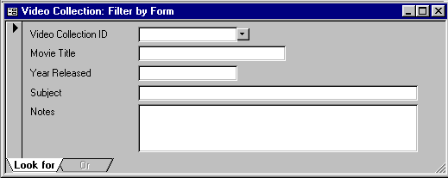If any of the fields on the form has any text, clear the form by clicking the Clear Grid button in the toolbar
- Click in the Year Released field: you could click on the down arrow and choose a particular year from the list
- But instead type the following: >1950 (using the greater than sign: usually this is on the same key as the full-stop)
- Having now created the filter, apply it by clicking the Filter tool
- Access will take you back to the data form: instead of looking at the whole table, you now have only the records that satisfied the filter criterion. Look at the bottom of the form where it will say something like Record 1 of 3 (Filtered)
- Click the Filter tool again. This takes the filter off, so that the whole table is again available
- Access remembers the latest filter. Click the Filter tool again, and the same filter as before will be applied
- take the filter off by clicking the Filter tool
- Before going on to the next section close the Video Collection Form by clicking the cross in the top right corner of the form
- be careful to click the cross on the form not the cross at the top of the whole Access window
- Access will ask if you want to save the form: answer Yes
- in the Save As dialog-box, just click OK

Querying the database
Filtering is adequate for most purposes when you are dealing with a simple table like this. But for more complicated databases you need to know how to construct queries.
If there were more tables in the database you could choose which to use in the query

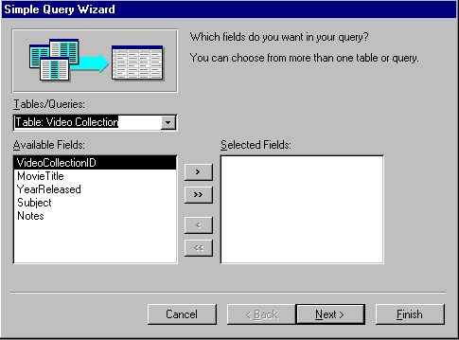
The query wizard
- In the Database window click the Queries tab
- Click the New button on the right of the Database window
- In the dialog-box choose Simple Query Wizard and click OK
The first thing the Query Wizard asks is which table and which fields you want to use in your query. At present we have only one table so we only have to select the fields
- Click on the Movie Title field in the list of Available Fields, and click the > button
- Do the same for the Year Released and Subject fields
- When you have selected these three fields, click Next to go on to the next part of the wizard
- In the next dialog-box select the Detail option and click Next
- In the next part
- accept the default title for the query: Video Collection Query
- choose the Modify Query Design option (because we need to include a search term in the query)
- click Finish

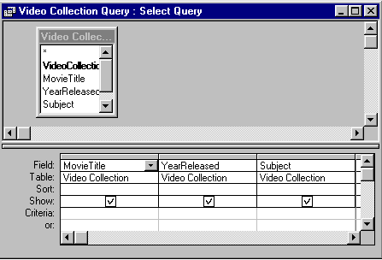
Modifying the query
Based on the information given to the wizard, Access has created the skeleton of the query. The query skeleton looks like this. In the top half there is a window showing the fields in the table on which the query is based; the lower half shows which fields we have chosen to show.
We shall now add a search criterion to tell Access that we want to retrieve only those records referring to movies released later than 1950.
- Click in the row labelled Criteria in the column labelled Year Released
- Type the query criterion: >1950
- Choose Run from the Query menu
Access will display the results of the query in a datasheet format – that is, in a table of columns and rows, like a spreadsheet. Check that the results are what you would expect from the query
- Click on the Design button in the top left corner:
- Back in the query design window change >1950 to read <1951
- In place of the Design button you will now see a Datasheet button: click on this, which will be the equivalent of running the query again, with the new criterion
- Close the query by clicking in the cross at the top right corner of the query window
- When asked if you want to save the changes to the query, answer Yes

Reports
We shall now use the query as the basis of a report. A report consists of two components: a report design, and the data. You first tell Access which table or query you want to use to provide the data, and then you design a form that will lay out the data clearly.
- 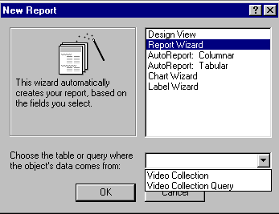In the database window click on the Reports tab
- Click the New button
- In the New Report dialog-box
- select Report Wizard
- at the bottom of the dialog-box choose Video Collection Query from the selection box
- click OK
- In the first step of the Report Wizard, click the >> button to select all available fields
- Click Next to go on to the next step
- Make no changes in the next two steps: just click Next twice
- In the next step under Layout choose Columnar and click Next
- In the next step, choose a style from the list and click Next
- In the final step type in a title (you can leave the default title as it is if you wish) and make sure the Preview the Report option is selected, and then click Finish
After a delay Access will display your report. It should show the same records as were displayed earlier when you ran the query on which the report is based.
- Close the report by clicking in the cross in the top right corner

Change the query ...
We shall now modify the query and see its effect on the report.
- In the database window choose the Queries tab
- Select the query called Video Collection Query and click Design
- In the query design window change <1951 to >1950
- Close the query window by clicking the cross in the top right corner
- When asked if you want to save the changes to the query design, answer Yes

... and look at the Report
- In the database window click the Reports tab
- Select the report called Video Collection Query and click Preview
The report will now show the movies dated after 1950. Did you expect this?
When you save a “report” Access only stores the design. Each time you preview or print the report it will go back to the table or query on which it is based and pick up the latest version of the data. When we changed the query, the output of the report changed. If the report is based on a table, its output will change to reflect any data that you add or change in the table.

Summary
We have seen three different ways of looking at the data in the table:
- looking at the table with the data form
- selecting particular fields and particular records with a query and looking at the results in a datasheet
- displaying the results of the query in a report
In this brief overview of Access we have not had to carry out all the usual steps because we have used wizards to do some of the work for us. In subsequent sections we shall go back over the same ground more slowly and see how to
- define tables
- design a form
- create queries linking more than one table
- modify a report layout

Section 2:
Create a table and form for data entry
A database table has two components: its structure and its data. You must define the structure before putting data into it. In the previous worksheet we did not explicitly define a table structure because we took the structure from one of the Table Wizard’s sample tables.
Defining a table’s structure consists of
- naming the fields
- saying what data type each field will contain
- specifying the size of each field – that is the maximum amount of data they can hold
In this worksheet you will create a table and use a simple data-entry form to enter some records in the table.
- To prepare for this worksheet
- if it is not already running, start up Access
- if your earlier database window (firstdb) is still open, close it by clicking the cross in the top right corner
You should now have an empty Access window
- Choose New Database from the File menu
- In the dialog-box select Blank Database and click OK
- 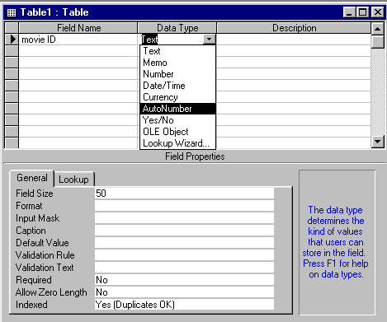You will be asked to name the new database: type in the name mymovies and click Create

Create a table
- Make sure the Tables tab is selected and click the New button
- In the next dialog-box select Design View and click OK
This will give you the Table Design window. In the top half of the window you will specify the field names and data types. In the lower half you will give the field size.
- In the first row under Field Name type movie ID and press Return
- Under Data Type Access will display the default field type, which is Text: to change this click on the down arrow and select AutoNumber from the selection list
This will make the Movie ID field an automatically generated serial number
- Press Return
- In the Description column you can enter a descriptive note: this is for your benefit – the computer doesn’t need it
- enter Automatic serial number and press Return
- On the next row under Field Name enter title and press Return
- under Data Type accept the default Text
- look under Field Properties in the lower half of the window: the Field Size for a Text field is, by default, 50 characters, which is about right as a maximum for a movie title, so leave it as it is
- press Return and enter a field description if you wish
- press Return again to move on to the next row
- Under Field Name type year and press Return
- under Data Type select Number from the list
- in the Field Properties part of the screen, click in the Field Size box
- click on the down arrow beside the box and select Integer from the list
- for Decimal Places delete Auto and enter 0
- Click in the next row of the Field Name column and type star1 and press Return
- again this is a text field, but this time we shall change the Field Size property: click in the Field Size box, delete the existing value and type 30
- Click in the next row of the Field Name column and type star2 and change the Field Size to 30
- Click in the next row of the Field Name column and enter other actors
- this field will be used for a list of other principal actors, so it can be quite long: increase the Field Size value to 100
- click in the Description column and enter a note to remind you how to enter data in this field – for example, type something like this: names separated by commas
- press Return to go on to the next row
- In the next row create a field with the Field Name director, Data Type Text and Field Size 30
- In the next row create a field with the Field Name producer, Data Type Text and Field Size 30
- In the next row create a field with the Field Name camera, Data Type Text and Field Size 30
- In the next row create a field with the Field Name notes, Data Type Memo
A memo field is a text field without any limit on the number of characters. Because of the way memo fields are stored they are not as efficient as text fields for certain purposes, but they are useful when you may want to include a large amount of text in your database.
- The definition of the table is now complete so close the design window by clicking on the cross in the top right corner
- Access will ask if you want to save the table design: answer Yes
- When prompted for a table name, enter my movies and click OK
- Access will ask if you want to create a primary key: answer No

Create a data-entry form
To make data entry easier we shall create a simple form, using the Autoform wizard.
- In the database window click on the Forms tab
- Click New
- In the New Form dialog-box
- choose the AutoForm: Columnar option
- where the dialog-box asks you to choose a table or query, select my movies
- click OK
A simple form based on the my movies table will be displayed. We should save it and give it a name.
- Choose Save from the File menu
- The Save As dialog-box assumes that you want to call the form by the name of the table on which it is based. Accept this by clicking OK

Enter Data
Now enter data for a number of movies. Note the following points:
- Don’t try to enter anything in the Movie ID field: it will be automatically entered
- Move from one field to the next by pressing either Return or Tab or by pointing and clicking with the mouse
- But in the final Memo field, pressing Return will not move you on to the next record as you might expect: you will either have to press the Tab key or click on the Next Record navigation button at the foot of the form
- If you’re not a filmgoer and can’t think of any real data, just make it up
- You don’t need to enter data in every field
Consult page 7 for more details on using the data-entry form.
- Enter two or three records in the table and then close the form
Note that when you close the form you will not be asked whether you want to save the data. Information is entered directly into the table as soon as you move on to the next field.

Example
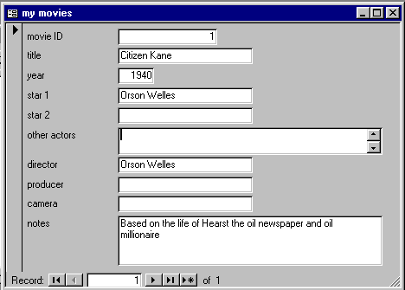
Click in the Title field and type a title, and then press Return or Tab.
Do not enter anything in this field.
Click on the Next Record navigation button to move on to enter another record.
Click on the Previous Record navigation button to go back to an earlier record if you want to modify the data.
Memo field: text will wrap-round as you type, as in a word-processor.

Using Expressions in Forms.

Purpose.
When calculating values in a Form expressions are used. Expressions are statements that are written down and that give a result after evaluation.
Examples:
In an employers database, if records are kept of the ‘Date of Birth’ of each employee, you can find out how old an employee is by subtracting the value in the ‘Date of Birth’ field from the value in the ‘Current Date’ field. The expression for this calculation is defined as:
=[Current Date]-[Date of Birth]
The value returned is the age of the employee as of the current date.
To insert the Current Date or Time to a form or a report the following expression can be used:
=Date() or =Now()
To automate data entry. This happens in situations when you want to automate certain fields in your form. For instance, when you want to calculate the Total in an Order Form, this value can be calculated automatically as data entry is going on.
The following mathematical operators can be used to perform calculations:
* / Multiplication and Division
+ - Addition and Subtraction
& String Concatenation i.e. when you want to join
together text like [First Name] & “ ” [Last Name].

Step-by-Step.
Choose the Text Box control and add it to the section of the Form where you would like to have the end result of the expression. The text box is the most common type of control to use for entering expressions.
Delete the Label section for the control.
You can type in the expression directly into the cell. However, if you would like Access to help you build an expression then continue with the rest of the steps.
Position the cursor in the Text Box and click the right mouse button and from the quick menu click on Properties.
From the Properties Sheet, choose the Data Tab.
Select Control Source and click on the Build button next to the down arrow key.
When you click on the Build button the Expression Builder is activated.
Type in the expression directly in the upper portion of the window.
OR
Build an expression using the Expression Builder.

Using the Expression Builder
In the lower grid, the screen is divided into 3 columns:

The first column contains categories which have expressions or even fields that are in common use. Some categories include Tables, Queries, Reports, Constants, Arithmetic Operators, Common Expressions and so on.
In the second column, select the description of the expression or the fields that you want to use e.g. Page Number.
The last column contains the actual expression with the correct syntax e.g. “Page” & Page.
Double-click on the expression to place it in the upper part of the window.

Examples of expressions:

Field | Expression | What it does
Date | Date() | Returns the current date according to the computer clock.
Date and Time | Now() | Returns the current date and time.
Prime Freight | [Freight]*1.1 | Calculates the prime freight which is 110% of Freight.
Total Amount | [Quantity]*[Unit Price] | Multiplies Quantity and Unit Price to give the Total.
Full Name | [First Name] & “ ” & [Last Name] | Joins or concatenates the first name and the last name.
Delivery Date | Date () + 10 | Adds 10 days from today’s date.
Address | [City] & “ ” & [Region] & “ “ & [Postal Code] | Joins the fields City, Region and Postal Code.

Creating and using Subforms
Purpose.
A sub form is a form within a form. It is created when you want to display or include information from more than one table in a form. It is also used to view related information from more than one table. For example, if you have two tables i.e. Products and Products Suppliers, you may want to create a form that displays both the information for a Product and for the Products Suppliers. In so doing you do not have to switch back and forth between Products form and Products Suppliers form.
Subforms are especially effective when you want to show data from tables or queries with a one-to-many relationship.
From the example above, a product can have many suppliers and so the product table represents the ‘one’ side of the relationship whereas the products suppliers represents the ‘many’ side of the relationship.

Step-by-Step.
Creating a Form and a Subform at the same time.
All the table relationships must be set correctly before attempting to create forms and subforms.
Switch to the Database Window.
Select the Forms tab and choose Form Wizard.
- The Form Wizard Dialog Box is activated.
- In the first step of the wizard, select a table or query from the drop down list.
- Click or select the fields you want to include from this table or query.
- Using the same dialog box, select another table or query from the list.
- Click on the fields that you want to include from this table or query.
- Click on Next.
- If the relationships between the tables are proper, the wizard moves on to the next step. Otherwise, you will get an error message and must set the proper relationship before proceeding.
- Select the table you want to view by. This table is going to serve as the Main Form.
- Click on the Form with Subform(s) option.
- Click on Next.
Select a layout for the subform. A subform can be viewed as either a form or a datasheet.
Follow the directions in the remaining wizard dialog boxes. When you click Finish, Access creates the two forms, one for the main form and subform control, and one for the subform.
Format the form using other controls to achieve the desired look.
Switch to Form View.

NOTES:
There are other ways of creating forms with subforms:
You can:-
Create a subform separately and add it to an existing form.
In this case, the table relationships have to be set properly.

Using the Toolbox.
Purpose.
When you display a form or a report in Design view, a toolbox is usually displayed.
The toolbox is a type of toolbar that is used to add controls to a form or report. It is also used when making changes to the different controls in the form or report.

Step-by-Step.
Switch to the Database window by clicking the F11 key.
Create or open a Form or Report in Design view.
When in either Form or Report Design view, click on the View Menu and select Toolbox to activate the toolbox.
OR
- If the toolbox is not visible, click on the Toolbox button on the toolbar.
- Click on the tool that you want to use to select it.
- Move the pointer onto the Form or Report.
- As you move the pointer, notice that the pointer changes to the picture in the tool.
- Click the Form or Report where you want to place the control.
- Resize the control if necessary by dragging the outline.

The most common types of control found on the toolbox include:

Label Controls
These are used to display descriptive text such as headings on a report or form; column titles like ‘Full Names’, or ‘Title’; captions or brief instructions. They do not display values from a field or expression as they are bound.
They are also static, meaning that they do not change as you move from record to record.
Labels are automatically included when you create most controls.

Text Box Controls.
Are used to display and accept a wide variety of data like names, addresses, phone numbers etc.
They can be bound to a field in a table or query.

List Box Controls.
Are controls that displays a list of values from which you can choose one value. It is mainly used when you want to limit entries to a form.
The list is always displayed in Form view.

Combo Box Control.
Is like a Text box and a List box combined into one control. You can either type a value in the text box or select a value from the list as you fill in the form. To see all possible values, use the scroll buttons to scroll through the list.

Note: When you choose either the List box or Combo box controls, the List box or Combo box Wizards are activated. These wizards enable you to either choose the tables or queries that contain the values to be used or allow you to type in new values for the list.

Option Button Controls.
Are controls that are used to indicate whether a situation is true or false e.g. whether an order has been sent or not.
When you click the button, a black button appears in its center to indicate the situation is true, otherwise the situation is false.

Check Box Control.
Is a control that is also used to indicate whether a situation is true or false e.g. whether one is single or married.
When you select the check box, a √ appears in it to indicate that the situation is true, otherwise the situation is false.

The Line Control.
Is used to display a horizontal, vertical, or diagonal line on a form. Lines can also be used to draw attention to important information, to group information, or to enhance the look of a form.

The Rectangle Control.
Is used to display a rectangle on a form. Rectangles are effective when grouping related information or emphasizing key areas on a form or report. They can even be used to create a ‘shadow effect’ by placing them behind other controls.

Other controls include:
Toggle Control
Page Break Control
Command Button Control
Image Control
Bound and Unbound Object Frames and
Subform/Subreport controls
These are used for a variety of other reasons ranging from creating page breaks, to displaying a form within a form.

POINTS TO NOTE:
Controls can be classified as Bound Controls, Unbound Controls or Calculated Controls.
Bound Controls have data sources from a field in a table or query. They can be used to display or enter values like text, dates or numbers from fields in your database. This means that the information they display is from an underlying table or query. A good example of this is a Text box label.
Unbound Controls do not have data sources. They can display information, lines, rectangles and pictures i.e. information that does not originate from a table or query. A good example of this is a Label control.
Calculated Controls have expressions as data sources. They can be used to display calculated values and may contain a formula or expression like: =[Unit Price]*.75

Re-think the structure of the data
Can you think of a problem that might arise with the table we have defined here? Suppose you wanted to search for all movies with, say, Ingrid Bergman in them: which fields would you search in? You would have to search in Star1 and Star2 and Other actors, which could become quite complicated.
The problem is that there is not a one-to-one relationship between actors and movies. Most movies have more than one actor, and most actors appear in more than one

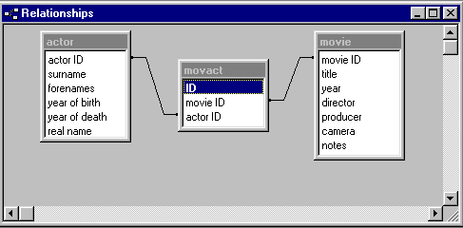

movie. This means that the data is too complex to fit into a single table. The diagram illustrates how three linked tables can be used to handle the information.
Each box represents a table and contains a list of the table’s fields. There are three tables: the actor and movie tables with movact in between linking them together.
Each actor and movie has a unique identifier, and the movact table consists of records linking actors to movies. The lines represent the relationships between the tables.
The next section will discuss the question of linked tables and “many-to-many” relationships.

Section 3:
Notes on database design
We shall now consider some of the issues of database design which were skated over in the previous section. You will not need to use the computer during this section.

Links between tables
The idea of linked tables was introduced at the beginning of Section 1, where we linked the author table to the publication table using a unique author identifier. Each author has his or her own unique number, which is used in the publication table to link each publication with its particular author. Each author can appear many times in the publication table, but only once in the author table. The relationship between author and publication is therefore a one-to-many relationship.
This works because we assume that each publication has only one author. If we try to allow for publications with more than one author (eg The Communist Manifesto by Marx and Engels) the relationship breaks down. There is no place in the records in the publication table for more than one author number. We can’t just introduce another field for “second author”. Can you see why not? One reason is that we would not know where to stop: what about works with three authors, or four? But the crucial reason is that even if there were two author-number fields in the publication table it would not be possible to link to the author table using both fields.
The relationship between authors and publications should be a many-to-many relationship, not one-to-many. A many-to-many relationship cannot be accommodated within the simple structure we have described so far.
We shall now explore these ideas in more detail, using two further examples. In addition to the business of linking the tables, these examples should give you a taste of another aspect of database design: trying to think ahead to decide what information you will need to record.

Example 1 – The Art Club

Scenario
You are the secretary of an art club and want to use a database to keep track of the artists, their pictures and people who buy the pictures. We assume that each picture has one and only one artist, and at most one purchaser; each artist may have several pictures in the exhibition, and there is no limit on the number of works any individual may buy.

The artist table
On a piece of paper list the fields you might want to include in the artist table. You will need various contact details, plus some biographical information that you might want to include in your catalogue. And don’t forget that you need to be able to link the artist with his or her works. Think what data type you should use for each field: is it a text field, or a number? If it is a text field, what length should it be – that is, what is the maximum number of characters you are likely to need for the field? Do you need to use a memo field – that is a text field which can grow to any length?
Indicate which fields you consider to be mandatory – that is, which fields must not be left blank when you are entering records in the table.

The picture table
Now list the fields that you think will be needed in the picture table. Again specify the data type and size of the fields. Remember that you need fields that will allow you to link pictures to artists, and pictures to purchasers. Indicate which fields are mandatory.

The purchaser table
Now list the fields that you think you will need for the purchaser table. As with the artist, you need contact details, and also the field that will allow you to link purchasers to pictures. Indicate which fields are mandatory.
Once you have jotted down your idea of the fields needed for the three tables, look at the lists below and compare them with your answers.
artist
artist ref number | autonumber | mandatory
forenames | text (50)
surname | text (30) | mandatory
address line 1 | text (60)
address line 2 | text (60)
address line 3 | text (60)
address line 4 | text (60)
postcode | text (20)
phone | text (20)
e-mail | text (40)
year of birth | number (integer)
biographical details | memo
picture
catalogue number | number (integer) | mandatory
title | text (50)
medium | text (15)
price | number (2 decimal places)
artist ref number | number (integer) | mandatory
purchaser ref number | number (integer)

purchaser
purchaser ref number | autonumber | mandatory
forenames | text (50) | mandatory
surname | text (30) | mandatory
address line 1 | text (60) | mandatory
address line 2 | text (60) | mandatory
address line 3 | text (60)
address line 4 | text (60)
postcode | text (20)
phone | text (20)
e-mail | text (40)

Notes
The relationship between artist and purchaser is a many-to-many relationship: for each artist there may be many people buying their pictures; each purchaser may be buying pictures from many artists. This relationship depends on the picture table which links artists to purchasers as shown here:
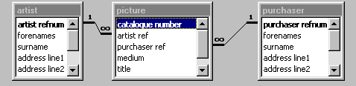
The lines on the diagram represent the links between the tables. You cannot draw a direct many-to-many relationship between two tables. The many-to-many relationship is established having two outer tables each of which has a one-to-many relationship (marked by the 1 and ∞ on the linking lines) with the central table.
Don’t worry if you haven’t got all the fields listed above. You may have thought of some which are not included. The important thing is to note the use of the reference numbers, which are what enable the tables to link together.
- Note the use of the autonumber data-type in the artist and purchaser tables. You used this feature on page 17. It ensures that each record in those two tables has a unique reference number. Do you see why the autonumber data-type is NOT used for the corresponding fields in the picture table?
- The reason is that when you put an artist ref or purchaser ref into a record in the picture table, it must be the number belonging to the relevant artist or purchaser, not an arbitrarily assigned number.
- Each record in the picture links with one record in the artist table, and with zero or one record in the purchaser table – in other words, every picture has an artist, but the purchaser ref number field in the picture table may be blank – some pictures remain unsold.
- The unique identifier in the picture table (the catalogue number) is not an autonumber field. This is because you may want to assign catalogue numbers yourself, perhaps to reflect the physical layout of the exhibition. Automatic numbering assigns a number reflecting the order in which records are added to the table. If a record is deleted, its number will not be re-used. This means that automatic numbering is probably not suitable for a catalogue number.
- When you are defining your table in Access you can specify that a given field is to be an index with no duplicates. This will ensure that the values are unique. In the case of the picture table this would mean that Access would not allow you to assign the same catalogue number to more than one picture.
If the lists of fields that you jotted down do not resemble the lists given above you should discuss any points of difference with the instructor before going on to the next example.

Example 2: The conference database

Scenario
You are organizing a conference, and want to use a database to keep records of the delegates. Some delegates are contributing papers at the conference, and some are contributing poster displays. You need the database to keep track of these contributions. Most contributions have more than one author, not all of whom are attending the conference as delegates; some delegates are authors of more than one paper or poster. Each contribution has one lead author, and one author (who may or may not be the same as the lead author) who is responsible for correspondence.
Read through the notes on the three tables and then jot down the fields that will be needed. Start with the tables containing data about people and contributions, and then consider how they are to be linked.

The people table
The people table must contain name and contact details, as well as various administrative details to do with the conference (fees paid, tickets sent, accommodation required, special dietary requirements and so on). We call it the people table rather than delegates or contributors because not all the people we are dealing with are actually coming as delegates, and not all will be contributing papers or posters. Obviously, for those who are not attending as delegates there will be many fields that are not relevant and will be left blank. Bear in mind that you will need a unique identifier for each person.

The contribution table
You will need the title of the paper or poster, plus an indication of whether it is a paper or a poster. Various ad ministrative information might also be needed, such as an indicator of whether it has been accepted, whether the abstract has been received, whether it is to be published in the conference proceedings and so on. You might include a memo field for the abstract, and fields for keywords. Each contribution must have a unique identifying number.

The pclink table
This is the people/contribution linking table. This table must contain the unique identifiers from the people and contribution records. Each person’s unique number can occur many times in the pclink table, and so can each contribution’s unique number – this is because contributions have multiple authors and individuals can contribute to several papers. But each pairing of person to contribution is unique: only one record in the table will link person number 3 to contribution number 44, and so on.
In addition to the linking information, there are some other details that belong in this table. The fact that person number 3 is the lead author of contribution number 44 is not a fact about the person or the contribution but about the link between the person and the contribution. The same person might be lead author of one contribution, but a subsidiary author of another contribution, so you must be careful where you put this information.
Once you have jotted down your idea of the fields needed for the three tables, look at the lists below and compare them with your answers. There may well be administrative details that you think of which are not included in the lists given below.
people
personal ID | autonumber | mandatory
forenames | text(50)
surname | text(30) | mandatory
title | text(10)
address line 1 | text(60) | mandatory
address line 2 | text(60) | mandatory
address line 3 | text(60)
address line 3 | text(60)
postcode | text(20)
phone | text(20)
e-mail | text(40)
delegate | yes/no | mandatory
application acknowledged | date
fee | number (2 decimal places)
payment received | date
nights accommodation | number (integer)
vegetarian | yes/no
contribution
contribution refe number | autonumber | mandatory
title | text(200) | mandatory
keywords | text(200)
abstract | memo
date abstract received | date | mandatory
acknowledged | date
decision | text(1): O=Oral paper; P=Poster; R=Rejected
date of decision | date

pclink
personref | number (integer) | mandatory
contributionref | number (integer) | mandatory
lead author | yes/no | mandatory
corresponding author | yes/no | mandatory

Notes
- The pclink table functions like the picture table in example 1. It links the people to c
- Contributions and includes some information that is specific to each particular pairing
- Access has its own way of specifying dates, so when you have a date field you should specify its data-type as date.
- Access has various other special types of field, including the “yes/no” data-type, which you can use where there are just two options.
- The decision field has three options: a contribution can be rejected, accepted as a paper or accepted as a poster. Rather than use the full words, it makes sense to abbreviate the data to a single letter. You can tell Access that only these three values (plus blank, meaning undecided) are acceptable for this field.
Once you have decided on the fields that you need, draw a diagram like that shown on page 27 to indicate the links between the tables. Show the result to the instructor before moving on to the next section.

Section 4:
Querying a database
In this section we shall work with a database that has three tables that have already been created and populated with data.

The movie1 Database

Open the database
- If Access is not already running, start it up as usual. If it is running, close all the open windows
- Choose Open Database from the File menu and use the dialog-box to locate and open the database movie1.mdb
- In the database window click on the Tables tab: you will see you have tables called movie, actor and movact

Look at the movie and actor tables
- In the Tables tab, double-click on movie
- This will launch the movie table: scroll up and down to look through the records in the movie table
- Open the actor table and scroll through to see the list of actors

Querying the database
We shall start with a simple single-table query, and then see how the tables can be linked to create more complex queries.

Querying the movie table
- Click the Queries tab in the database window
- Click New
- Choose Design View and click OK
- Two windows will be displayed, the query-design window called Query1 and Show Table windows: in the Show Table window click the Tables tab
- Select movie from the list of tables and click Add
- We are only using one table for this query, so click Close to close the Show Table window
The query design window consists of two parts: the top part shows which tables are involved in the query; in the lower part you can select which fields from the table(s) are to be used. You can use the fields in several different ways in constructing your query:
- you must choose at least one field to be displayed in the answer
- you can specify values to search for in particular fields: these are known as the query criteria
- you can use fields as the basis for sorting the answer
We shall run a query to list the titles and dates for all the movies, listed in date order, starting with earliest.
- Complete the first column in the lower part of the window as shown below
1 Click on the down arrow in the Field box and choose Title from the list of fields
2 Access will automatically fill in the name of the table
3 Leave the Sort box blank as we shall not sort on the title
4 Access will put a tick in the Show box: leave it there as we want to display the movie titles
5 Leave the Criteria box blank: we want to display all the records. You fill in the Criteria box if you want to select certain records and leave out others
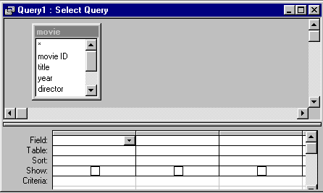

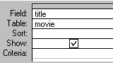
- Your first column should now look like this

- Now select options for the second column
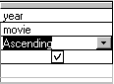
- click in the top row of the second column of the query grid
- click on the down arrow and choose Year from the list of fields
- in the third row choose Ascending to sort the records in chronological order starting with the earliest
- your second column should now look like this
- To run the query choose Run from the Query menu
The results of the query will be displayed in datasheet format, as shown on the next page.
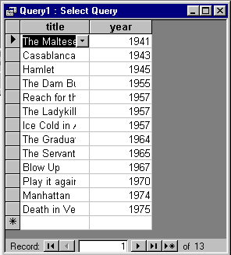
Point here at the line between the column labels. When the pointer becomes a double-headed arrow, double-click
Point here, and when the pointer becomes a double-headed arrow, double-click.
The first column is too narrow and the second is too wide for the data they contain. You can correct the widths by pointing and double-clicking

- 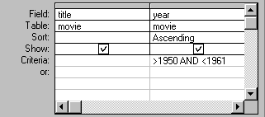Go back to Query Design view by choosing Design View from the View menu or clicking the button
- Add a query criterion in the Year column of the query design window
- Click the button to run the query

Comparison operators
The greater than and less than signs (> and <) are known as comparison operators and it’s important to be clear what they mean. Which of the following years are included by the criterion used here, >1950 AND <1961:
1950? | 1951? | 1960? | 1961?
The other comparison operators are
>=  greater than or equal | <=  less than or equal | =  equal | <>  not equal

Save your query
- Choose Save from the File menu
- In the dialog-box type a name that describes the query, for instance 1950s and click OK
- Close the query
The query will now be listed in the database window. You might wonder why the Save As dialog-box is not like other Save As dialog-boxes in Windows applications. The reason is that you are not saving the query as a file. Your queries, as well as tables, forms and everything, are all stored within the one database file.
What you have saved is the query not the answer. If you add new records for films from the 1950s, and then run the query again, you will get a different answer, including the newly added (or changed) records.

A linked-table query
- Make sure the Queries tab of the database window is still selected, and click the New button
- In the dialog-box choose Design View and click OK
- In the Show Table window click once on actor in the list of tables
Press the Shift key and keep it down while clicking on movact and on movie – you should now have all three tables highlighted
- Click Add and all three tables will appear in the top part of the Query window
- Close the Show Table window – Access won’t let you do anything else until you have closed this window
- The movact table is conveniently in the middle. If it weren’t, you could move the tables about in just the same way as you move other windows about: point at the title bar, press the mouse button and drag
- Now establish the links between the tables:
- point at the actor ID field in the actor table
- press the mouse-button and drag across to the actor ID field in the movact table – then release the mouse-button
- point at the movie ID field in the movie table
- press the mouse-button and drag across to the movie ID field in the movact table – then release the mouse-button
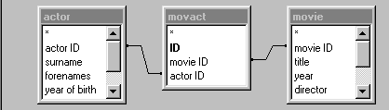
Your links should look like this
- In the lower part of the query design window, click on the arrowhead in the Field box in the first column: you will see that all the fields from all the tables are listed. You can use any of the fields in your query
- Set up a query which will retrieve all the actors in the database in movies made after 1960 and sort the output in chronological order starting with the earliest. List the forename and surname of the actors, the titles of the films and the years
Try to specify the query without looking at the illustration on the next page, but use the illustration as guidance if you need to.
If you make a mistake when choosing a field, you can delete a column from the query design window by clicking somewhere within the column to be deleted and then choosing Delete Columns from the Edit menu.
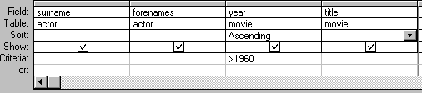
Your query design should look like this
- Click the Run button and make sure you get the answer you expect
- Save the query, calling it after60
- Modify the query criterion in the year column to <=1960
- Run the query and make sure you get the answer you expect
- Now save the query under a new name:
- choose Save As/Export from the File menu
- in the Save As dialog-box choose Within the Current Database and in the New Name text box type a new name, such as upto60
- click OK
You should now have three queries listed in the database window. You will be using some of them later, so make sure they have been correctly saved:
- Double-click on the after60 query and look at the results: does it list the films made after 1960 as you would expect?
- Close the after60 window
- Double-click on the upto60 query and make sure it lists the fims made up to 1960
- Close the upto60 window
If anything seems not quite right, ask about it before carrying on.

A more complicated example
The next example involves making a comparison between fields in different tables. We want to find movies in which the director was also an actor. We shall do this in two different ways.

(a) List the movies where the director is known
Not all the movie records have any information in the Director field. This first query will list all the movies where the director is known, and you can inspect the answer to see for yourself where the director and actor are the same.
- Make sure you still have the Query tab selected, and click the New button
- Choose Design View and click OK
- Add all three tables and establish the links, just as you did before
- In the lower part of the query design window create a query as follows:
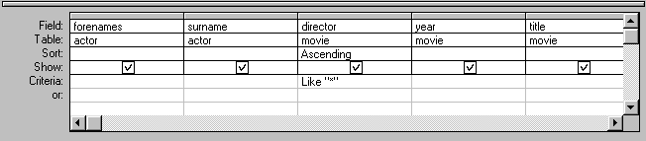
The Like “*” criterion will select all records which have any value at all in the Director field. The same result would have been achieved by entering not Null as the criterion. Note that * is the asterisk (wildcard) sign, which you will find on the same key as the number 8.
- Run the query and check that the answer is what you expect
- Save the query, calling it directors

(b) Compare directors and actors
In (a) we only got the computer to do half the job. It told us which movies had directors recorded in the database, and we then had to look at the list and decide for ourselves whether the director was the same as any of the actors given. We shall now modify the query so that instead of selecting all the directors, we only select those with the same surname as one of the actors in the films.
- Click the Query Design button
- Delete Like “*” and enter a new criterion (without any spaces): =[actor].[surname]
Note that the equals sign is needed; the brackets are square brackets, not round.
- Run the query: you should get two movies in your answer
- Use the Save As/Export command to re-save the query as actdirect
If you think about what we have done here, you will quickly see that there is a fundamental flaw in our database design. We have made a comparison between the Director field in the Movie table and the Surname field in the Actor table. This obviously assumes that we don’t have several people with the same surname.

A query based on other queries
We want to know whether we have actors who appeared in movies made up to 1960 and also in movies made after 1960. To do this we shall link together our two queries and create a further query based on them.
Before we do that we must include the actor ID field in both those queries: can you see why this is desirable?

Modify the two queries
- Click on after1960 and then click Design
- We want to add a further column to the query, so click in the first column (the surname column) and choose Columns from the Insert menu
- In the blank column choose the actor ID field
- Close and save the query
- Do exactly the same in the upto1960 query

Creating the new query
We are now ready to make a comparison between the results of the two queries to see if any actor appears in both sets of movies.
- In the Queries tab click New
- Select Design View and click OK
- In the Show Table dialog-box click the Queries tab
- Add the two queries, after1960 and upto1960 and then click Close
- Make a link between the actor ID field in after1960 and the same field in upto1960
- Add fields to the Query Design as shown here:
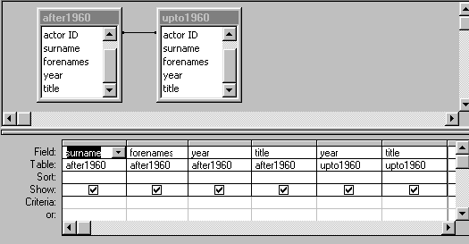
Obviously you only need include the actor’s surname and forenames from one of the two original queries, since we are only looking for cases where the actor is the same in both after1960 and upto1960.

- Run the query as usual: you should find one case

In this section you have seen a number of different querying techniques, with queries based on a single table, on linked tables and finally on two linked queries. The next worksheet will return to the three linked tables that we have used here, and look at how to enter data into linked tables.

AND and OR
We saw on page 33 how two conditions could be combined using AND: we wanted to choose those records where the film came out after 1950 AND before 1961, so we used the complex criterion >1950 AND <1961. Both parts of the complex condition had to be satisfied.
Sometimes we have a complex condition where we want either one part OR another to be satisfied. In this case we place the two parts on separate lines of the query grid.
- Create a new query using the movie table, as follows:
- Make sure the Queries tab of the database window is still selected, and click the New button
- In the dialog-box choose Design View and click OK
- In the Show Table window double-click on movie in the list of tables
- Close Show Tablewindow
- Add the title, year and director fields to the grid by double-clicking on each in turn
- We want to find the movies produced in 1963 OR 1967:
- under year click in the criteria row and type 1963
- click in the next row and type 1967
The lower part of the query window should now look like this:
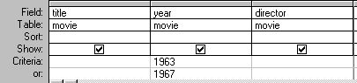
- Run the query, and you should retrieve those movies where the year is 1963 OR the year is 1967, but no others
- Go back to design view to modify the query
- Now we shall retrieve the films produced in those two years, but only where the director is known
- click in the criteria row under director and type is not null
- click in the next row and type is not null
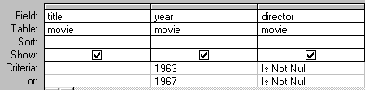
Note that you must put the “is not null” condition in both rows; if you only put it in the first row your answer would include films produced in 1967 whether or not the director was known.
- Run the query and you should retrieve those movies where the year is 1963 AND the director is not blank, OR the year is 1967 AND the director is not blank

Update records using Queries.

Purpose.
When you want to make changes to group of records in one or more tables all at once you can use an updata query.
For example, when you wish to raise the price of a particular commodity in your database by 10%; or when you want to increase the salaries for people within a certain job group by 5%.

Step-by-Step.
- Create a new query in design view.
- Select the table from which you want to update records. It should contain the field you want to use for setting criteria.
- Add the field(s) you want to update to the query design grid by double clicking on the field.
- Change the query from a Select query to an Update query. To do this, select Query from menu bar and choose Update Query option.
OR
Click on the Query Type button and select Update.
- The Query changes to an Update query and the ‘Update To’ row is added to the grid.
- In the ‘Update To’ cell, type in the expression that you will use to update information in your table.
- To see a list of the records that will be updated or the result of the update, click the Datasheet View button on the tool bar. This is because once you update the records, you cannot reverse the action.
- After viewing the changes that will take place, switch back to Design view.
- Run the query.
A warning message appears informing you that the update action cannot be undone.
- Click on Yes.

The table below gives a few examples of expressions which can be used for updating records:

Expression | Result
“Mombasa” | Changes value to Mombasa
#8/12/97# | Changes date values to 12-Aug-97
[Order Details].[Unit Price]*[Order Details].[Quantity] | Calculates the product of Unit Price and Quantity, both in the Order Details table.
[Salary]*1.5 | Increases the Salary value by 50 percent.
Yes | Changes No values in a Yes/No field to Yes.
“Shs” &[Fees] | Concatenates (adds) the prefix Shs to the beginning of each specified amount of fees.

Delete records using Queries.

Purpose.
Deletes a group of records that meet the same conditions. These records may be from one or more tables.
For instance, you could use a delete query to remove products that are discontinued and for which there are no orders.

Notes:
- With delete queries, you always delete entire records, not just selected fields within records.
- It is faster to use a delete query than to delete each record separately.

Step-by-Step.
- Create a new query that contains the table from which you want to delete records.
- Click on the Query Type button on the toolbar to display the Query options, then select Delete. The Delete Row is added to the table.
- From the table which you want to records, drags the asterisk (*) form the field list to the Query Design Grid.
- The words ‘From’ appears in the Delete cell. This indicates that the values deleted will be from the table customer information.
- To specify the criteria fro deleting records, double click on the fields on which you want to set criteria.
- ‘Where’ appears in the Deleted cell and will allow you to set criteria for the records you want deleted. i.e. ‘Number’
- In the criteria cell enter the criteria for the fields that you have selected, this will enable you to select the records you want to delete
- View the records that will be deleted first, to ensure that you are not deleting the wrong records.
- Run the query
- The warning screen appears. Click on yes to complete the action.

Append records to a table using queries

Purpose.
- When you want to add records from one table to another existing table or to create another table with the same records from an existing one.
- Records can be appended (added) to a table in the same database or to another database. E.g. Paradox, Dbase, Fox-Pro etc.

Step-by-Step.
- Create a query that contains the table whose records you want to append to another table.
- In query Design view, click on Query Type button at the toolbar, and then select Append. The Append dialog box appears.
- In the Table Name box, type the name of the table you want to append records to, or select the table from the drop down list.
- Click Current Database to put the query results to a table in the database open currently. In cases where another database is to be used enter the table name, click Another Database option, and then type the filename of the database.
- Click OK.
- Double-click on the fields you want to append from the field list, the fields should include the ones for setting the criteria, and the primary key field.
- Type in the name of the fields you want to append to in the Append To row.
- In the Criteria cell for the fields that you have dragged to the grid, type the criteria to select the records you want.
- View the records to verify the results before running the query.
- Run the query.

Create tables using a Make-Table Query.

Purpose.
Creates a new table from all or part of another table. Retrieving the records and using them to create a new table. These newly created tables can be used to create reports, make backups or even to split tables and so on.

Notes:
- A table created by the query has the same data types and field size properties as the original table.
- Primary key and other field properties are not inherited. They have to be set afresh.

Step-by-Step.
- Create a new query based on a table or query that contains the records you want to put in the new table.
- On the Query menu click on the Make-Table option or click on Query Type button on the toolbar, and then select Make-Table. The Make Table dialog box appears.
- In the Table Name box, type the name of the table you want to create or click the name of a table you want to replace.
- Click Current Database to put the new table in the database open currently, or click Another Database and type the name of the database you want to put the new table in.
- Click OK.
- In the Design view, double click on the fields you want to appear in the new table you are about to create.
- View the records before running the query.
- Run the query.
- Click Yes to complete the task.
- The new table can be viewed from the Database Window.

SQL
You have seen how to design queries using the query design grid. Access translates the query you have designed into Structured Query Language (SQL), which is a standard query language used in many database management systems. You can view, and modify, the SQL directly. To see how the complex query you have just created translates into SQL, take the following steps:
- Choose SQL View from the View menu
The SQL window shows the following query:
SELECT movie.title, movie.year, movie.director
FROM movie
WHERE (((movie.year)=1963) AND ((movie.director) Is Not Null)) OR (((movie.year)=1967) AND ((movie.director) Is Not Null));
The present workbook does not cover SQL, but you can gradually get an idea of the basic elements of the language by looking at the SQL for your queries. Note that there are three main steps in constructing the query:
- SELECT: specify which fields you want to retrieve, which corresponds to selecting a field in the top row of the query grid and putting the tick in the Show box under the field name
- FROM: say which table(s) is/are being used for the query
- WHERE: specify the criteria to be applied in selecting records
If you want to confirm the connection between the SQL view of your query and the query design grid, try changing the SQL:
- For instance, delete 1963 and type 1948 in its place
- Run the query again and note the result
- Go to design view and you will see that the criterion has been changed there too

Section 5:
Data entry into linked tables
In this section we shall again work with the three-table database and see how Access makes it easy to enter data into linked tables.
If you think for a minute you will see that there is a problem with entering data into tables that are linked using an arbitrary reference number. If I want to record that Steve McQueen was an actor in the film Bullitt I have got to know the correct reference number for Bullitt. I may be dealing with hundreds of films – have I got to know all their reference numbers by heart? Fortunately Access has ways of ensuring that we always use the correct number without the necessity of remembering the numbers ourselves.
We shall look at a database in which the relationships between the tables have already been established, and see how this enables us to set up a form for data entry. In section 6 we shall go back over the steps needed to set up the relationships and create the form.

The fully linked database

Open the database
- If Access is not already running, start it up as usual. If it is running, close all the open windows
- Choose Open Database from the File menu and use the dialog-box to locate and open the database movie2.mdb
The tables are the same as you used in the previous worksheet. This version of the database contains a form which is based on the three tables linked together.
- In the database window click on the Tables tab: you will see you have tables called movie, actor and movact

See how the tables are linked
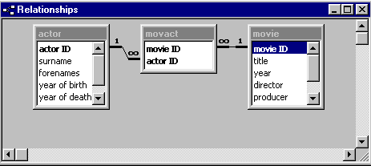
You will remember that both tables have an “ID” field, assigning a unique number to each movie and each actor. In the queries that you constructed in the previous worksheet you used these ID fields to link movies to actors, using the movact table as an intermediary “junction” table. The movact table has just two fields: each record in the table links a movie to an actor. Many of the movies and actors appear more than once in this table, but no linking pair is repeated more than once.
- Choose Relationships from the Tools menu
The Relationships window illustrates the links by means of lines running between the linking fields. Note the 1 and ∞ symbols that indicate the one-to-many relationships (see above, page 27). For every one record in the actor and movie tables there are zero, one or many records in movact.
Actors who don’t appear in any of the movies in the database, and movies that don’t feature any of the actors in the database, will not be represented at all in movact. Since actors can appear in several movies, and movies can feature several actors, both actors and movies might occur any number of times in movact.
The relationship between actor and movie is a many-to-many relationship: for each actor there can be zero, one or many movies; and for each movie there can be zero, one or many actors. Since databases cannot support many-to-many relationships between tables, we must establish the relationship by means of the junction table.

Referential Integrity

Keyed fields
Earlier on we ignored the issue of creating a primary key. Now we need to think about it. There are several reasons for defining fields as key-fields, one of which is that it enables Access to establish “referential integrity” between linked tables. This means, roughly, that Access can ensure that you don’t enter inconsistent data in your linked tables. For example, it will prevent you from referring to an actor in the movact table if they don’t occur already in the actor table.
- Close the Relationships window by clicking on the cross in its top right corner
- In the Database window click the Tables tab
- Click on the Actor table
- Click Design to go to Table Design View
- Notice the little key icon beside the actor ID field, indicating that it is the primary key
The way to make a field a primary key is to select the field by clicking, and then click the Key button on the toolbar. Clicking this button again will cancel the key. Don’t do this now, as we want to leave the actor ID field as the primary key.
- Close the Actor table
- Open the Movie table in Table Design View
- Note that the movie ID is marked as a primary key and then close the table
- Open the movact table in Table Design View
- Note that both fields in this table are marked with the key symbol, meaning that both fields together constitute the primary key
- Close the table
The actor ID and movie ID fields together constitute the key, which means that
- an actor can appear more than once in the table
- a movie can appear more than once in the table
- any particular pairing of an actor with a movie, can only appear once

Enforcing referential integrity in the Relationships window
Having seen what is meant by a keyed field, we’ll go back to the Relationships window to learn more about the relationships between our three tables
- Choose Relationships from the Tools menu
- Point at the line running from movact to actor and click
If you have clicked in the right place the line will become thicker, indicating that you have selected the relationship. It is quite hard to click in exactly the right place, so you may have to try several times before successfully selecting the relationship.
- Choose Edit Relationship from the Relationships menu
This command will not be available unless you have succeeded in selecting a relationship.
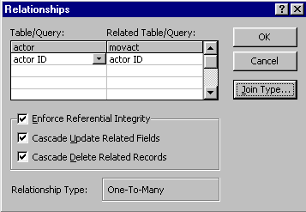
The dialog-box shows you which fields are involved in the relationship, and that the relationship is “one-to-many” (both of which we knew already), and also what sort of referential integrity is in force.
The significant point for our database is that the Cascade Delete Related Records option is turned ON. Now if you delete an actor from the actor table, all records in the related table (movact) that refer to the deleted actor will also be deleted. This maintains referential integrity by ensuring that there are no actors referred to in movact who are not already in the actor table
- We don’t want to make any changes, so click Cancel
- Now click on the link between movact and movie and choose Edit Relationship from the Relationships menu
- Check that the relationship is defined in just the same way as for the actor/movact relationship and then click Cancel
- Close the Relationships window

The data-entry form
Having seen behind the scenes, we shall now look at the data-entry form. Because a form must be based on a single table or a single query, it is necessary to create a query using all three tables and displaying all fields and all records. The form is then created automatically, based on this query.
- To see what the query looks like, go to the Queries tab, click on Links and click Design
Note that all the fields are to be displayed. The ID fields of course occur twice, in movact and in either actor or movie. We have chosen to take these fields from the movact table.
- Close the query
- Click on the Forms tab
There are two forms listed. The movact subform is part of the main movie form, as you will see.
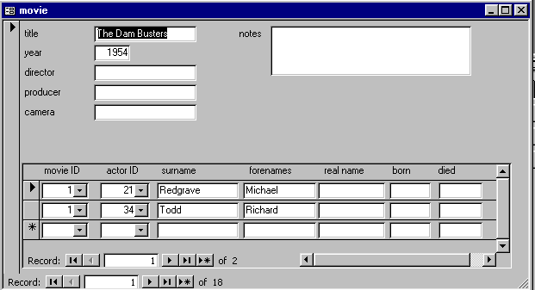
- Double-click on movie
Navigation for main form: moves from one movie to another
Navigation for subform: moves down list of actors linked to the current movie.
You should be familiar from an earlier worksheet with the navigation buttons on the form, which enable you to move backwards and forwards within the table, and to jump to the first or the final record. Because there is a subform on the movie form, there are two sets of navigation buttons. Make sure you know which is which.
- Use the main form navigation buttons to move about within the movie table
- Where more than one actor is listed in the subform, use the subform navigation buttons to move down or up the list of actors associated with the current movie

Adding records
- Click the New Record button (marked with an asterisk) on the main form, to add a new movie to the database
- Click in the Title box and enter Magnificent Seven
- If you know the director and year and any other information, enter it in the appropriate boxes on the main form
- On the subform (which is empty so far) click in the surname column (first row) and type Brynor
- In the forenames box type Yul
- Click in the surname field on the second row
Note that values have been automatically entered in the movie ID and actor ID fields, as you have entered both a new movie and a new actor.
- Write down on a piece of paper the number shown in the movie ID field
- A second star of the film was Steve McQueen, so enter his name in the surname and forenames columns
- Now click the New Record button on the main form so that we can enter the name of another movie
- In the title field enter Bullitt
- If you know them, enter the year and any other information about this film, but don’t enter any actors yet
The star of Bullitt was Steve McQueen. If you now enter his name as you did for the last movie, you will put a duplicate record into the actor table. The way to link Steve McQueen with this second film is by selecting his record from the drop-down list in the actor ID field.
- Click on the down arrow beside the actor ID field in the subform
- Scroll down and select McQueen from the list
If you can’t see it in the list it means the last change that you made has not yet been registered, so choose Refresh from the Records menu
When you choose an actor from the actor ID drop-down menu, the relevant details are picked up from the actor table and displayed on the form.
- Write down on a piece of paper the number shown in the movie ID field

What is happening when we enter records on the form?
Entering the movie details on the main form is straightforward – just like entering data on a simple form as you did in Worksheet 2. The subform is more complicated.
The subform offers you two options:
- if the actor already exists in the actor table, pick him or her from the drop-down menu – to avoid duplicate records you should always check this first
- if it is a new actor, enter his or her details in the surname, forename and other fields
What about the movie ID and actor ID fields?
- never enter anything yourself in movie ID: it always takes its value according to the movie that is referred to in the main form
- only use the drop-down menu to choose a value for the actor ID field
For every actor you enter in the subform, whether it is a new actor or an existing actor, Access creates a new record in the movact table linking the actor to the movie referred to in the main form. You can look at the movact table to confirm that this has happened:
- Close the form
- In the database window, click the Tables tab
- Double-click on the movact table
- Check that there are records in the table referring to the two films you have added – you took a note of the movie ID numbers. There should be two records for The Magnificent Seven and one for Bullitt.
- Close the movact table

Deleting records
If you delete a record in the main form, you are deleting a movie from the movie table. Access will delete the corresponding records in the movact table, but will not delete the actors from the actor table.
If you delete a record in the subform, you are only deleting a record from movact. Although the actor’s details will no longer be displayed in the subform, nothing will be deleted from the actor table.
Even if you delete all the records in the subform, you will not delete the movie – you will simply have a movie without any links to actors.
- Go back to Forms tab and open the form
- Delete some of the records that you have just entered
To delete a record from the movie table, click in a field on the main form and then click the Delete Record button.

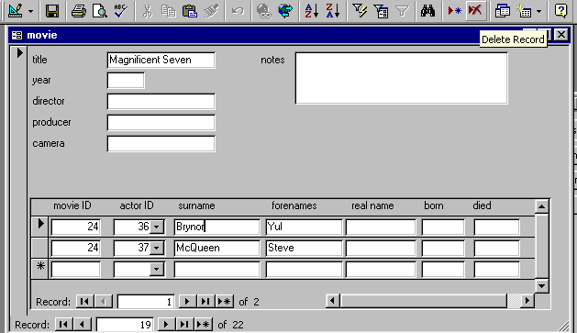
The picture reminds you that it is important to notice where the cursor is before you click the Delete Record button.
The cursor is in the subform: if you click the Delete Record button the record will be deleted from movact.

Do you think it is possible to delete records from the actor table using this form?

In the next section we shall return to a version of the database in which the tables are still unlinked, and go over the steps needed to set up the form we have just been looking at.

Section 6:
Setting up linked tables
In the previous section we saw that Access makes it easy to enter data into linked tables using a a form. In this worksheet we shall go back over the steps needed to set up the relationships and create the form. The database movie3 contains just the three tables, movie, actor and movact. No links have yet been established between them.

Open the database
- If Access is not already running, start it up as usual. If it is running, close all the open windows
- Choose Open Database from the File menu and use the dialog-box to locate and open the database movie3.mdb
- In the database window click on the Tables tab: you will see you have tables called movie, actor and movact

Establish referential integrity
Referential integrity is explained on page 45. You may like to refer back to that page before following these instructions which will take you quickly through the steps needed to establish referential integrity between your tables.
The first step is to set up primary keys in the three tables.

The actor table
- In the Tables tab, click once on actor and then click the Design button
- In the design window click on the actor ID field
- Click the Primary Key button in the toolbar (represented by a key symbol)
This will place a key symbol beside the actor ID field, indicating that it is the primary key
- In the Field Properties section at the bottom of the design window, look in the Indexed selection box and make sure you have chosen the option Yes (No duplicates)
- Click the Save button in the toolbar and close the table

The movie table
- Follow the same sequence of steps with the movie table: make the movie ID field a primary key with no duplicates
- Save and close the movie table

The movact table
In the movact table we need a primary key which consists not of a single field, but is made up of the two identifiers (movie ID and actor ID) together.
- Click on movact and then click the Design button
- Select the movie ID field: you will have to click on the grey square just to the left of the field name
Notice that the mouse-pointer changes shape when you point at this little grey square; and when you click the whole row is selected.
- Press the Shift key and keep it down while clicking in the little grey square to the left of the actor ID field
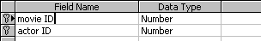
- Now both fields should be highlighted: click the Primary key button and the key symbol will appear beside both fields
- Click on the actor field normally (ie not in the little grey square, but just on the field name; and don’t press Shift)
- Now you have selected just the actor ID field, look down at the field properties, and under Indexed it should show Yes (Duplicates OK)
- Click on the movie ID field and check that the Indexed property here also says Yes (Duplicates OK)
- Save and close the table
Do you understand why duplicates are OK in the movact table, but not in actor or movie? If not, ask.

Setting up the Relationships
- Choose Relationships from the Tools menu
- In the Relationships window, point at the actor ID field in the actor table, press the mouse-button and drag a line across to the actor ID field in the movact table
- The Relationships dialog-box will appear when you release the mouse button
- select the Enforce referential Integrity option
- also select the other two options: Cascade Update Related Fields and Cascade Delete Related Fields
The illustration on page 46 shows what the dialog-box should look like.
- click Create to create the relationship
- Follow the same steps to create a relationship between the movie ID field in the movie and movact tables
- Close the Relationships window

Creating the form
Forms have to be based on a single table or query. Since we have three tables, we must unite them into a single query. Look back at section 4 if you are not sure about how to create queries.

The linking query
- Click on the Queries tab and click the New button
- Select Design View and click OK
- Add all three tables to the query and then click Close to close the Add Table dialog-box
Access already knows about the links between the tables, so there is no need to draw them again.
- Click in the Field box in the first column of the query design window, click on the down-arrow beside it and choose movact.movie ID from the list of fields
The movie ID field occurs twice in the list of fields, because two tables contain a field with that name. Make sure you choose the field from the movact table, not from the movie table.
- In the second column, select movact.actor ID - again, choose the field from the movact table
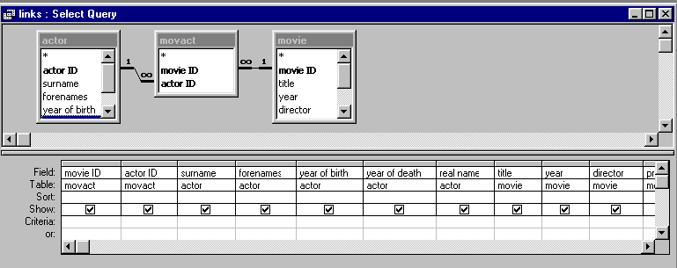
- Now add all the other fields (apart from movie ID and actor ID from the movie and actor tables so that the query design window looks like this –
- When you have added all the fields, click the Save button in the toolbar
- when asked for a name, type in the name links and click OK
- Close the query window

The Form wizard
- Click on the Forms tab and click the New button
- In the New Form dialog-box
- in the selection box at the bottom, select links
- click on Form Wizard
- click OK
- Step 1: click on the >> button, which will transfer all the fields from the Available Fields panel to the Selected Fields panel, and then click Next
- Step 2: under How do you want to view your data? click by movie
Make sure Form with subform(s) is selected, and then click Next
- Step 3: select Tabular and click Next
- Step 4: select a style – Standard is a good one to choose – and then click Next
- Step 5: accept the suggested titles for the form and subform, and select the option Open the form to view or enter information and click Finish
The Form Wizard will create a form almost exactly the same as the one you used for data-entry in section 5, but there are some differences. For example, the fields in the subform are wider than they were in the form you used before. You can modify the layout of the form created by the wizard. The process of designing a form is similar to that of designing a report layout, which is described in the next section, so you can come back later to experiment with it if you like.

A combo box
The main difference between what you have now and what you used in the previous section is that when you were entering data you were able to choose the actors’ names from a “pick list” in the actor ID field, so that you didn’t have to know the identifying number of each actor. This sort of selection list in a form is known as a combo box.
- Close the form created by the wizard
You will notice that there are two forms now listed in the database window: movie and movact Subform
- Click on movact Subform and click the Design button to go to the form-design grid
Right-click on the actor ID field
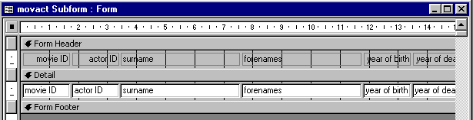
- Point at the actor ID field on the form and press the right mouse button
- from the pop-up menu choose Change to and from the sub-menu choose Combo box
- Right-click on the actor ID field again, and choose Properties from the pop-up menu
This will cause a small window to be displayed, labelled Combo Box: actor ID. This is the Properties window. There are a number of tabs in the window for the different categories of property that you can define.
Because the actor ID combo box is currently selected, the properties displayed are those of actor ID. If you click on another field or any other object on the form, the property window will display the properties for that object.
Don’t worry if you don’t understand about properties at first. You will have more practice with the Properties window when you come to design reports. For now, just follow the instructions blindly.
What we are going to do is tell the combo box to display the names of the actors so that we can choose an actor by name and Access will automatically choose the correct actor ID number.
- Make sure the actor ID combo box is selected
- if it is you will see little black squares called “handles” round it, and the Properties window will be labelled Combo Box: actor ID
- if it is not selected, click on it to select it
- In the Properties window click on the Data tab
- Click in the property labelled Row Source and type the following:
SELECT [actor ID], surname, forenames FROM actor ORDER BY surname;
This is a piece of “SQL” (Structured Query Language – see page 42), and it tells Access which fields are to be displayed in the combo box, and also what order they are to be displayed in. The square brackets are needed round the field name “actor ID” because it contains a space.
- Make sure the Bound column property is 1
- Click on the Format tab
- Change the Column Count property to 3
- Enter the following in the Column Widths property: 0.5cm;2cm;2cm
- Enter 4.5cm in the List Width property
- Save the movact Subform and close it
- Now double-click on the movie form and you should find you have a selection list to enable you to select the actors by name
You should have a form looking roughly like that shown on page 47.
- Use your new form to add another record to the movie table and a linked record to the actor table in the way described on page 47

In this section you have seen some of the mechanisms used by Access to create a form that makes data-entry simple. You have seen that this involves defining index fields in the tables; setting up referential integrity; creating a query; and using the combo-box feature to create “pick lists”.

Section 7:
Simple Reports
After completing section 4 you should have a number of queries saved in your database, including after60, upto60, directors and actdirect. This worksheet will give brief instructions on how to construct reports based on some of these queries. In case you did not save these queries earlier on, use the database movie4.mdb, which contains the necessary queries.
- If it is not already running, start up Access
- Open the database movie4.mdb
A “report” is a layout that you define and save. Each time you “run” the report Access retrieves the current data and uses that to produce a printable report. You design a report by placing boxes on the sheet and linking the boxes to fields in your database. The field that is linked to a box is known as the box’s control.

A simple report
- In the database window, click on the Reports tab
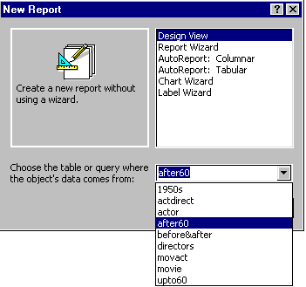
- Click the New button
- In the New Report dialog-box:
- click on Design View
- in the selection box labelled Choose the table or query ... select after60
- click OK
A new window will open showing a grid on which you can place the fields that you want your report to display.
- You should also see a new tool box beside the new window. If you don’t see it, choose Toolbox from the View menu
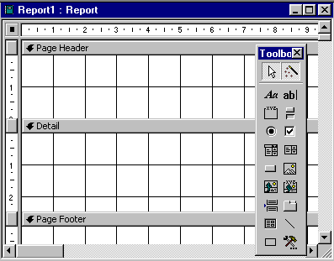
- Click on the Text Box tool in the toolbox
Label tool
Text box tool
A
B
- The mouse-pointer will become a cross-hair:
- point at roughly the position marked A in the illustration
- press the mouse-button and drag down to the point marked B
- then release the button

The Properties window
Is the Properties window open? You encountered the Properties window while creating a form in section 6. It allows you to specify in detail how you want the various objects on your form or report to look and behave.
- If the Properties window is not showing you need to open it as follows:
- 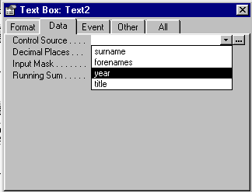Point at the rectangular text box you have drawn and click the right mouse-button
- A pop-up menu will appear: choose Properties
- If you have just opened the window, it will be referring to your new text box already. If you did not need to open it, because it was already open, you should make sure it is referring to your text box, by clicking on the text box to make it active
- In the Properties window click the Data tab
- Click the down arrow in the Control Source box and choose year from the list
- You can leave the Properties window open as you will need it again. If it gets in the way, you can move it around the screen by pointing at its title bar and dragging, just as you would do with any other window.
- The rectangular text box is now bound to the Year field in your after60 query
- If you look carefully at the text box you will see that Access has automatically put a label beside it. We don’t want labels on the report, so you need to click on the label (not on the text box as a whole) and delete it
- Point and click on the “Te” which should just be visible to the left of your text box. You will know you have clicked on the right place if you see the little black squares (known as “handles”) round the label, not round the whole text box – as shown here
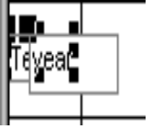
The “label” box selected, ready to be deleted
- 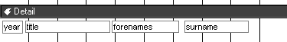Press the Delete key to delete the selected label – make sure you have deleted the correct thing: you should still have the text box with the word “year” in it
If in doubt about this procedure, be sure to ask the instructor. This illustration shows what you are aiming for.
- Perhaps your “year” text box is too big, bearing in mind that it only needs to contain four digits. Re-size it as follows:
- click on the text box so that the handles appear round it
- point at one of the handles on the right-hand side of the text box
- the mouse pointer will become a double-headed arrow: press the mouse-button and drag towards the left to reduce the size of the text box
- Next to your “year” text box, create a text box for the Title field – follow the same steps:
- click on the Text Box tool
- drag a rectangle (larger than the one you created for the year)
- click on the Data tab in the Properties window
- in the Control Source box choose Title from the list of fields
- click to select the label box and delete it
- Now create text boxes in the same way for the Forenames and Surname fields
- At this point it would be sensible to save the report (choose Save from the File menu)
- give the report a name – you could call it after60 report
- Preview the report by clicking the Preview button in the main toolbar
- You should see the report starting something like this:

1963 Hud Paul Newman
1963 The Trial Jeanne Moreau
1963 The Trial Anthony Perkins

Modify the simple report
There are two things wrong with the report as it stands: there’s no header and the rows are too far apart.
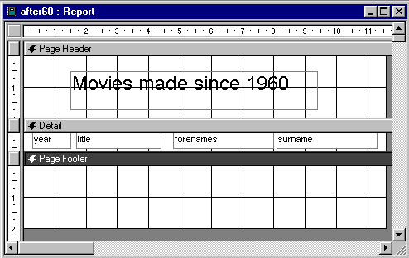
- Click the Close button to close the print preview and return to designing the report (this means the button labelled “Close” in the “Preview” toolbar at the top of the screen, not the close box in the top right corner of the window)
We want the report design to end up looking like this

(a) Add a heading in the Page Header section of the report
- Click on the Label tool (see the picture on page 58) and then drag the outline of a rectangle in the Page Header section of the design grid.
This rectangle is a “label box”.
- In the label box type a suitable heading: Movies made since 1960 for example
- Click outside the label box
- Click on the edge of the label box so that the black squares (handles) appear all round it
The handles indicated that the label box is selected – you can now format the text
- In the formatting toolbar at the top of the Access window is the usual sort of Font Size selection box: choose (say) 18 – you can experiment with formatting the text as you wish – bold, italic, colours
- You may have to increase the size of the label box, in the same way as you re-sized the text box earlier
- Save the report again

(b) Bring the rows closer together
- Make sure the four text-boxes containing your field names are as high as they can be up against the bar labelled Detail
- point and click on one of the text-boxes to select it: the “handles” should appear to show that it has been selected
- point at the selected box, avoiding the handles: the mouse-pointer will become a hand
- when the pointer becomes a hand, press the mouse button and keep it pressed as you drag the box up hard against the Detail bar
- do this for all four text-boxes
- Drag the bar labelled Page Footer as high as you can so that it is immediately under the row of boxes. Do this as follows:
- point at the top of the Page Footer bar
- when the mouse-pointer becomes a double-headed arrow, press the mouse-button and drag upwards
- release the mouse-button when you have dragged right up to the row of text-boxes
You have now reduced the space occupied by each line of the report as far as you reasonably can.
- Use the Preview button again to see the effect
- Save the report

Aligning your text-boxes
By dragging the text-boxes hard up against the “detail” bar you have in effect ensured that the row of data on the report will be well aligned. The printed report will show the data just as you have laid it out, and if your text-boxes are mis-aligned, the data will appear in a crooked line. To get more practice with manipulating the text boxes, try the following.
- Make sure you have saved your report as it is, because we are going to mess-up your nice alignment in order to practise putting it together again using a slightly different technique
- Drag the Page Footer bar downwards to give your self more room
- Drag the text-boxes down a bit to make them out of alignment
- Now select all the text boxes at once, as follows:
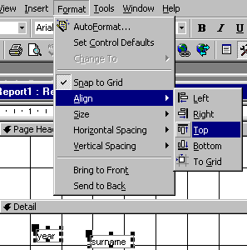
- click on the year box to select it: note the handles that appear round it showing that it is selected
- press the Shift key, and keep it down while clicking on the surname box: note that both boxes are now selected together
- keeping the Shift key down, click on the remaining text-boxes until they are all selected together
- Choose Align from the Format menu, and then choose Top from the sub-menu
Your boxes should now all be aligned with each other.
- While the boxes are still all selected, point at one and press the mouse-button and drag them all up to the top, right under the Detail bar
- Drag the Page Footer bar right up tight under the row of boxes
- Preview the report to make sure it is back to how you want it to be, and then save it again

Grouping the fields
For some of the movies there are several rows in the report, one for each actor. At present the report repeats the year and title in every row, which is rather untidy. We shall now group the rows so that there will be a separate “header” for each title.
- Point at a blank part of the report grid and click the right mouse-button
- Choose Sorting and Grouping from the pop-up menu
- 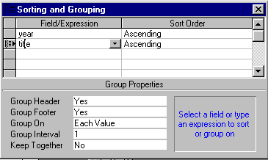Complete the Sorting and Grouping dialog-box as follows:
- click on the arrowhead under Field/Expression
- from the menu choose year
- now go to the next row and again click on the arrowhead
- choose title
- go down to the Group Properties part of the dialog-box and select Yes for both Group Header and Group Footer
- Close the Sorting and Grouping window by clicking on the cross in its top right corner
Your report grid will now have sections headed title Header and title Footer
- Drag your year and title boxes up into the area headed title Header
- You can drag the remaining fields to the left if you wish
- Draw a line in the title Footer section to separate one group from the next:
- click on the line tool in the report design toolbox
- point somewhere towards the left of the title Footer section and press the mouse-button
- drag across to the right, keeping the line straight, and release the button when the line is long enough
- drag your line right up to the top of the title Footer section
- Reduce the area occupied by the title Header and title Footer:
- point at the bar labelled Detail
- when the pointer becomes a double headed arrow press the mouse-button and drag up to bring the bar as close as possible to the year and title boxes
- release the mouse-button
- point at the bar labelled Page Footer
- when the pointer becomes a double-headed arrow press the mouse-button and drag to bring the bar right up to the line you drew in the title Footer section
- release the mouse-button
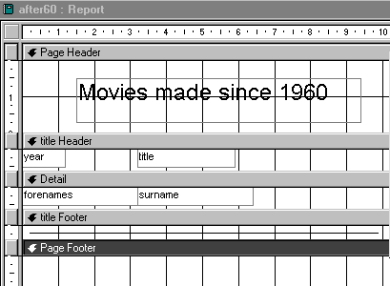You should end up with your report grid looking like this.
- Preview the report: if it does not look as you expect, ask the instructor
Most people find report design a bit confusing at first, but you will soon find it becomes more familiar.

Using Calculated Controls in Reports.

Purpose.
A Calculated control on a form or report is a control that does not display data that is stored in a table or a query. Instead a calculated control is used to display the result of an expression.

An expression is a combination of operators (such as + or =), controls names, field names, functions, and constant values.
The following expression calculates the price of an item with a 15% discount by multiplying the value in the Unit Price field.

=[UnitPrice]*0.85

Such controls are useful when storing computed values e.g. Totals or Averages of the invoice amounts for customers, totals of other invoice amounts like Grand Total, VAT etc. because these values are recalculated each time a value in the expression changes.
The fields that are generated when the report is displayed are known as calculated fields e.g. Grand Total, Dates etc.

Step-by-Step.
To Calculate a Total for a Group of Records or All Records in a Report
Ensure that you are in Report Design view.
In the Report Design View, click on the Text box tool. This is because the Text Box control is the most common type of control to use to display a calculated value. However, some other types of controls with a Control Source property can be used. This can be verified using the Properties window.
On the report, click where you want to display the final calculated value. In most cases, the result of the calculation is displayed in any of the following sections: Group Header or Footer, or Report Header or Footer.
If the control is a Text Box, you can type the expression directly in the control.

Note: When using a calculated control, every expression that is typed in must begin with an ‘=’ sign.
You can use the Expression Builder to create expressions. To do this click on the Build Button to activate the Expression Builder.

To Calculate a Grand Total for All Records in the Report
Add a Text Box to the Report Footer section.
Type in the expression to add all the Totals.
Preview the report and verify the results of the calculations or expression.

Tip:
If the report is based on a query, it may be wiser to place the expression in the query instead of having the calculated control in the report.

Creating and using Sub-Reports.

Purpose.
When you want to combine two or more different reports.
In such a situation, one of the reports serves as the ‘Main report’ and the other reports are referred to as ‘Subreports’. A subreport is a report that is inserted into another report.

For example, you may use the Main Report to show general information, such as report titles, and then use the subreports to show detailed information, such as the Total Sales for each region.

Step-by-Step.

Creating the Subreports.
Create a report the usual way i.e. using either the Report Wizard or the controls on the toolbox.
Save the subreport using an appropriate name.

Inserting and Subreport into the Main Report (Combining)
Press the F11 key to switch to the Database window.
Open the Main Report in Design view.
Drag the Subreport icon from the Database window to the ‘Detail’ section of the Main Report.
The subreport is inserted as a control on its own.
Adjust the positions of the Subreport controls and the attached labels, if necessary.
Change the format the text in the label for the Subreport Control to serve as a subheading for the section e.g. Region 1 Sales.
Change the view to Report View or Print Preview to see the final output.

A report using the actdirect query
Create a new report based upon the actdirect query. Your design grid should end up looking something like this.
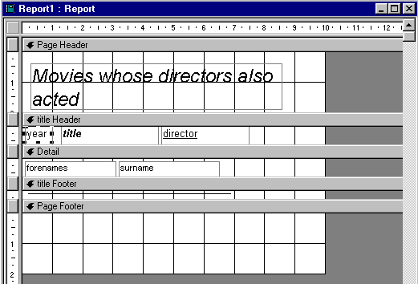

Show your report to the instructor. There is a separate booklet dealing with Access reports, which you can move on to now.

Create and use a Switchboard.
Purpose.
To make it easier to use or navigate between the forms and reports in your database.
This is especially useful when the forms and reports are many and the order in which they are to be used is not predictable.
You can create a Switchboard using the Switchboard Manager.

Step-by-Step.
Open the database for which you want to create the Switchboard. The database must contain at least some forms and some reports.
On the Tools menu, select Database utilities, and then click Switchboard Manager.
Click Yes.
The Switchboard Manager dialog box appears.
Click Edit.
The Edit Switchboard dialog box appears.
Type a name for the Switchboard in the Switchboard Name box.
Click New.
In the Edit Switchboard Item dialog box, type in the text you would like to appear on the switchboard button. For example, type the name ‘View Reports’.
Click on the arrow besides the Command box and choose Open Report from the drop-down list.
The Switchboard box changes to Report box.
In the Report box, click the name of the report that you want to open whenever you click on the switchboard button.
If you want to open a form instead, choose Open Form in Edit Mode in the command box. This time, a Form box will be displayed.
Click OK. The item is added to the list of items found on the switchboard.
To add other items to the Switchboard, repeat steps 8 through 11.
Click Close.
A switchboard form and a table with Switchboard items are created and can be seen from the Database window.

Using the Switchboard.
Select the Forms tab, and open the Switchboard.
Click on the buttons to open the various forms or reports, or to return to the Main Switchboard.
Add any graphics and enhancements to the form by switching to Design View.

Section 8:
MACROS

CREATING MACROS
- In the database window, click on the Macros tab

- Click the New button
- In the Macro dialog-box:
- click on Action on the top pane
- in the list box Choose an action from the list e.g Add menu, Close , Open form etc
- From the action Arguments tab, Choose the query, form, table reports etc from the name section
- Change the view to what you desire i.e design view, datasheet view, form view, or print preview or even print a report.
- Run the macro by clicking on the Exclamation mark on the standard tool bar
- Save the macro with a new name before closing it.
